Data types

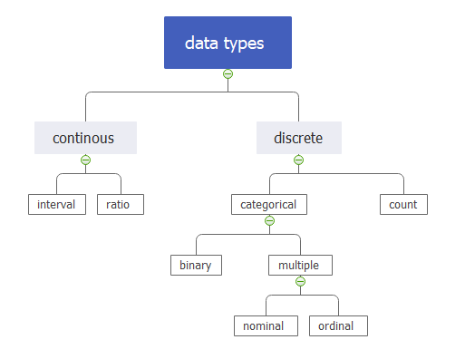

Continuous data :

A continuous variable can take any values.If that number in the variable can keep counting, then its a continuous variable
- Measure the jumping distance in long jump
- Speed calculated in bike and car racing’s
- calculate boundaries distance in cricket
- Calculate bowling speed in cricket
- Dimensions of a ground
- Miles to stadium from your location
- Annual income of the player
- Match running time

Discrete data:

A discrete variable can take only a specific value amongst the set of all possible values
- Number of goals hit in football
- Players killed by a player in PUBG
- No of wickets taken by a bowler
- number of matches played in a game
- Number of jockeys participated in horse racing
- No of runs scored in a cricket match
- Number of players
- Number of audience present

Interval data:
whose differences are interpretable, but the numerical attributes do not have the correct reference point or we can call zero point
- difference between two batsman scores
- Team rankings
- players performance -5 star ,4 star,a3 star,2 star,1 star
- ticket price -low,medium,high
- number of games won between two teams
- compare the degree of temperature on game day and before game day
- Difference between the two bowlers economy rate
- bat prices between two brands

Ratio data:
A ratio attribute is a numeric attribute with an fix zero-point. If a measurement is ratio-scaled, we can say of a value as being a ratio of another value
- Audiance capacity in a stadium
- Suppose if you bet 100 rupees then you earn 200 rupees
- How far is the ground from your home
- Players are scored twice as runs compare to previous match
- Ticket price for particular side
- What is the number of rockets a player can buy.
- A team is efficiently scoring runs but not won the cups

Categorical data:

Categorical Data is the data that generally takes a limited number of possible values. Also, the data in the category need not be numerical, it can be textual in nature
Two types : binary and multiple
Binary data:
Binary data has only 2 values/states. For Example yes or no, affected or unaffected, true or false
- win or loss
- Batsman out or not out
- Team enter into the final or not
- Attend the match or not
- goalkeeper stops the goal or not ?
- Applying different strategies or not
- Target reached or not
- Success or failure
Multiple data:

Multiple data is discrete data that can be in more than two categories
- Team names - india, australia,newzland etc
- Type of games - cricket,carrom , football etc
- Type of colour balls in snooker
- IPL team names - RCB , CSK,DD etc
- Monthly salary for players - below 5cr ,5cr to 10cr, above 10cr
- Rank the teams from highest to lowest rating

Nominal data:
The values of a Nominal attribute are name of things, some kind of symbols.
- logo of the team
- Brand names of bat or ball
- Player name
- Name of the team
- Name of the tournament
Ordinal data:

Ordinal data are discrete integers that can be ranked or sorted.
- Player performance rating on scale pf (1 to 5)
- I prefer cricket to football
- sindhu is playing well compare to saina
- how much audiences are satisfied with team performance
- Reebok bat is more costly than SS bat
- Team performance (low,medium,high)

Count data :

Count data represents number of occurrences of an event within a fixed period
- Number of catches missed in a match
- Number of matches played in a single day
- Number of goals stopped by a goalkeeper
- Number of wickets taken by a bowler
- Number of centuries in a tournament
- Number of jockey’s participated in horse riding

Structured data :
It is represented in the form of rows and columns. Easily understandable.
- Player information
- Game equipment cost data
- Team performance data
- Ticket cost price data
- runs scored for each batsman in a match
- Online games price data
Unstructured data:
It cannot be displayed in rows and columns and it isn’t so easily organized or formatted including formats like audio, video, and social media postings.
- Commentary
- Live match video recording
- Photos
- Tweets
- Audience reviews
Balanced data:
A balanced data set is the one that contains equal or almost equal number of samples from the positive and negative values.
- Century or not
- Win or loss
- Success or failure
- Audience liked the match or not
- Enter into the final or not
- First or not
- Killed or not
- Yes or no
Imbalanced data:
It typically refers to a classification problem where the number of
observations per class (positive & negative) is not equally distributed.

High difference between both values like 80% & 20%
- India win 2matches lost 8 matches in a series
- 20% audience attended in a match
- 80% success and 20% failure rate for portugal team in football
- Out or NOTOUT
- KILLED or NOTKILLED in pubg
Cross sectional data:
It is a collection of observations (behavior) for multiple subjects
(entities) at single point in time.

- Data collected on a single tournament
- Data collected on player performance
- Data collected on team performance
- Data collected on number of audience attending in a match
- Data collected on highest country economy based on their performance for last year
- Data collected on scoring runs ,boundaries in a single match

Real time data processing:

Real time data processing involves a continual input, process and output of data. Data must be processed in a small time period.
- Audience Services
- Bank ATMs
- Weather forecasts
- Real time retail dynamic pricing
- Social analytics for dynamic selling

Batch data processing:
Batch data processing is an efficient way of processing high volumes of data is where a group of transactions is collected over a period of time. Data is collected, entered, processed and then the batch results are produced. Batch processing requires separate programs for input, process and output.
- Online ticket booking bill generation
- payroll service
- billing systems.
- Financial report generation
- Processing of images in bulk

